EMBEDDED SYSTEMS-III

1.Write the Arduino code for blinking an Led and execute the simulation

A).

*Program:*

void setup() {

pinMode(1,OUTPUT);

}

void loop() {

digitalWrite(1,1);

delay(500);

digitalWrite(1,0);

delay(500);

}

*Simulation:*

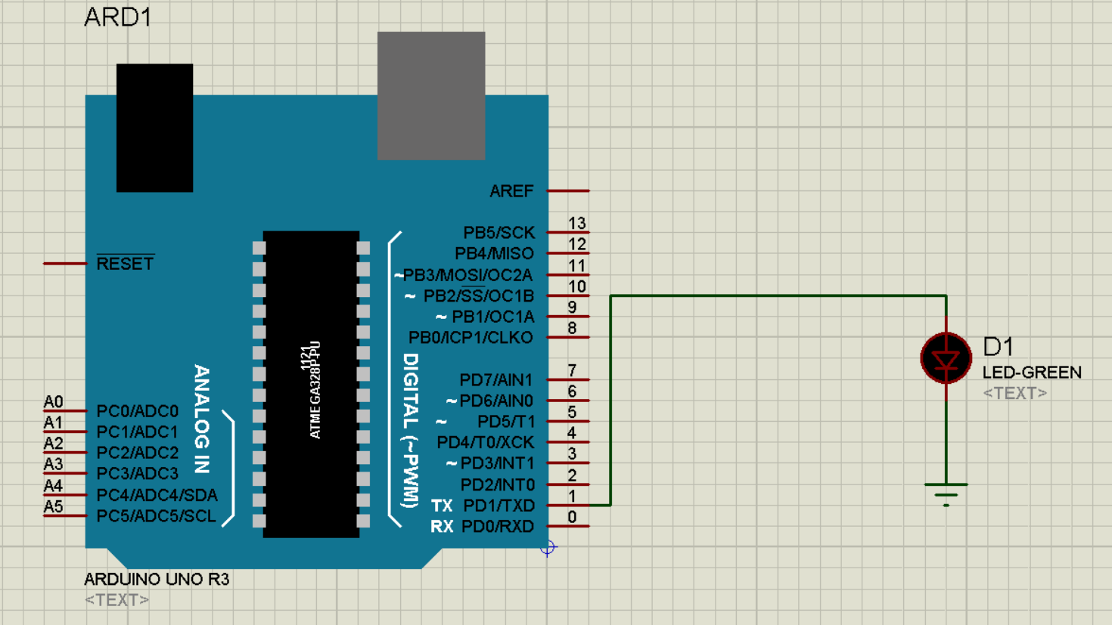

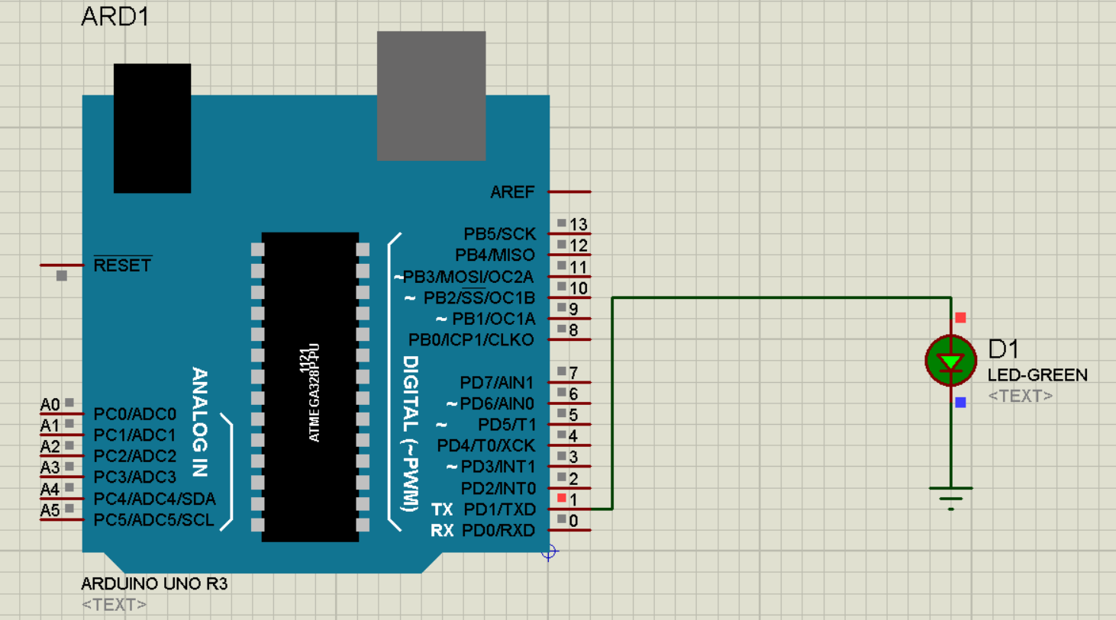

1.2) 2 Led Blink

A):

*Program:*

void setup() {

// put your setup code here, to run once:

pinMode(1,OUTPUT);

pinMode(2,OUTPUT);

}

void loop() {

// put your main code here, to run repeatedly:

digitalWrite(1,1);

delay(1000);

digitalWrite(1,0);

digitalWrite(2,1);

delay(1000);

digitalWrite(2,0);

}

*Simulation:*

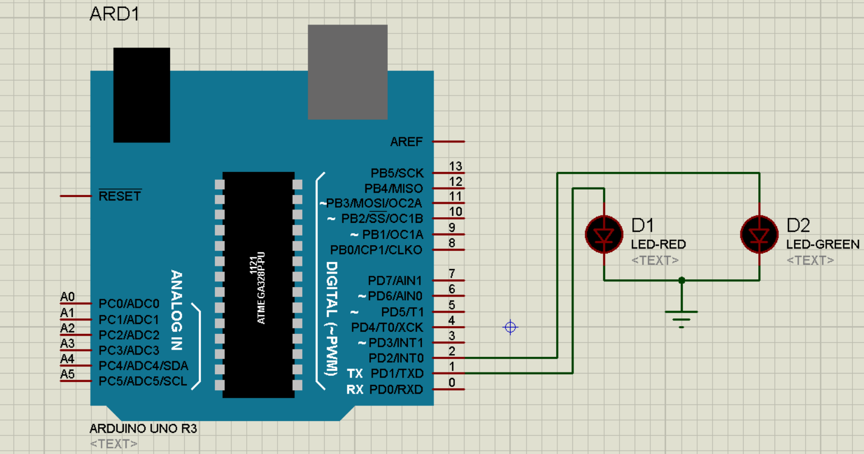

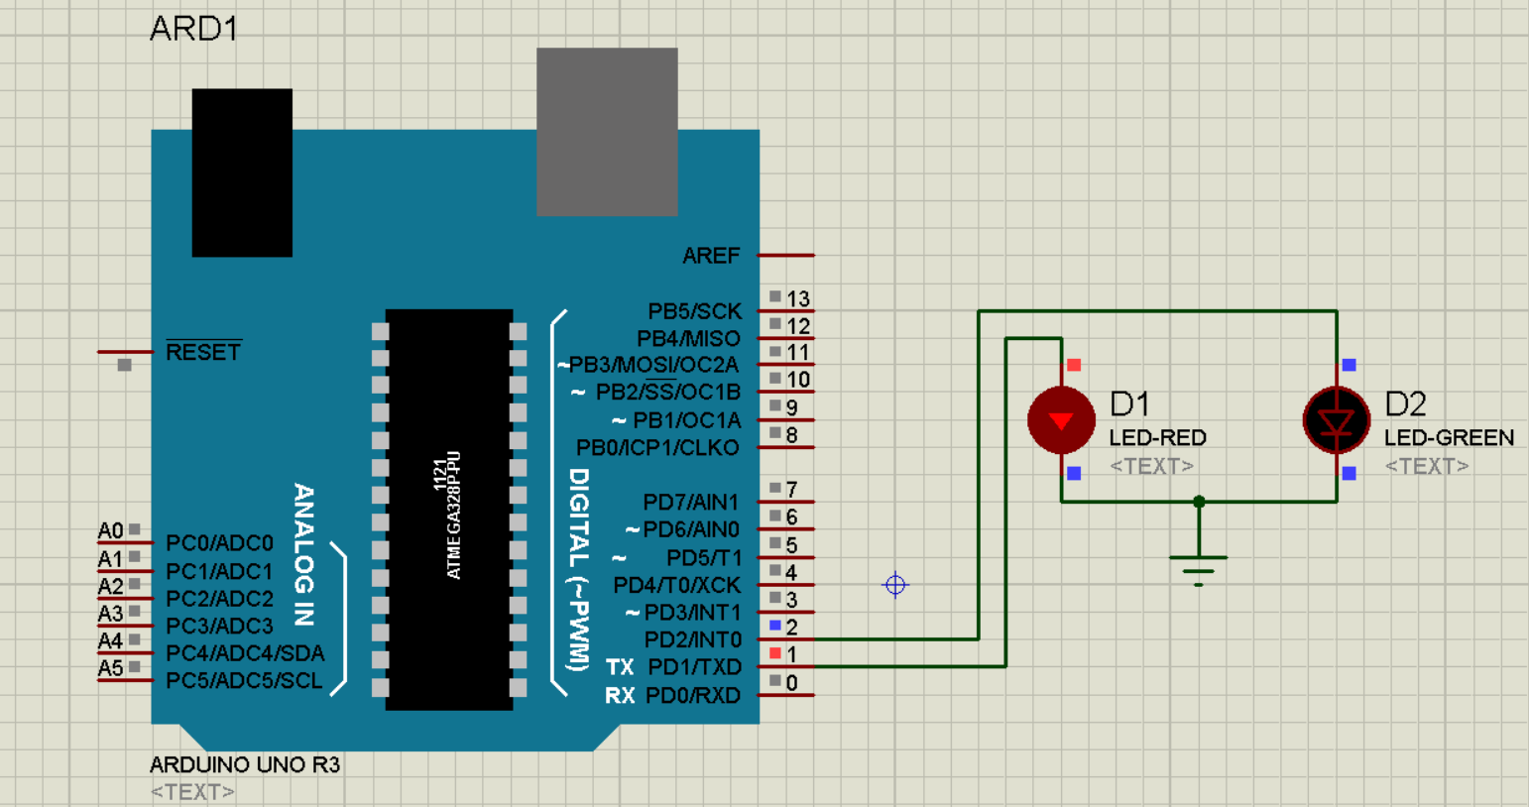

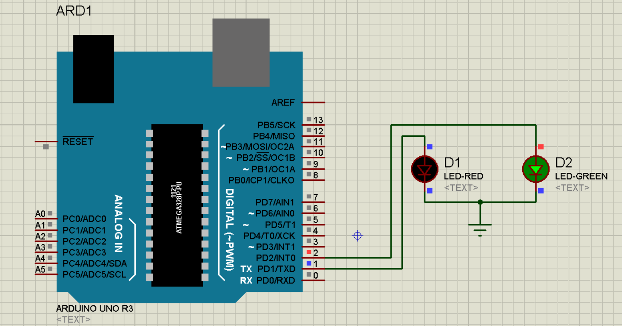

2.Write the Arduino code for blinking an Led using Switch and execute the simulation

A).

*Program:*

void setup() {

pinMode(1,INPUT);

pinMode(2,OUTPUT);

}

void loop() {

int a=digitalRead(1);

if(a==1)

{

digitalWrite(2,1);

delay(100);

}

else

{

digitalWrite(2,0);

delay(100);

}

}

*Simulation:*

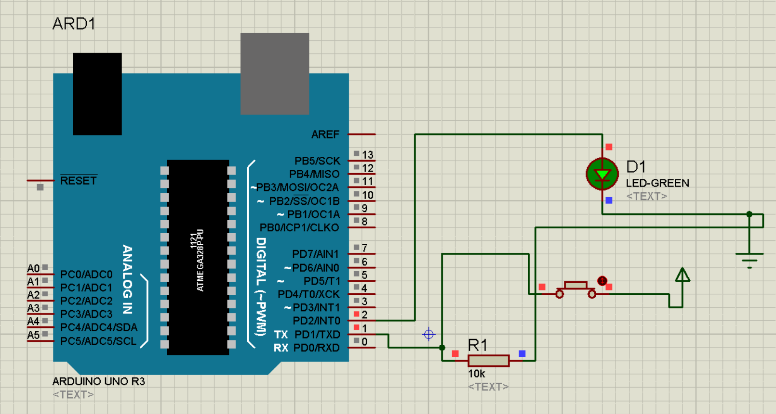

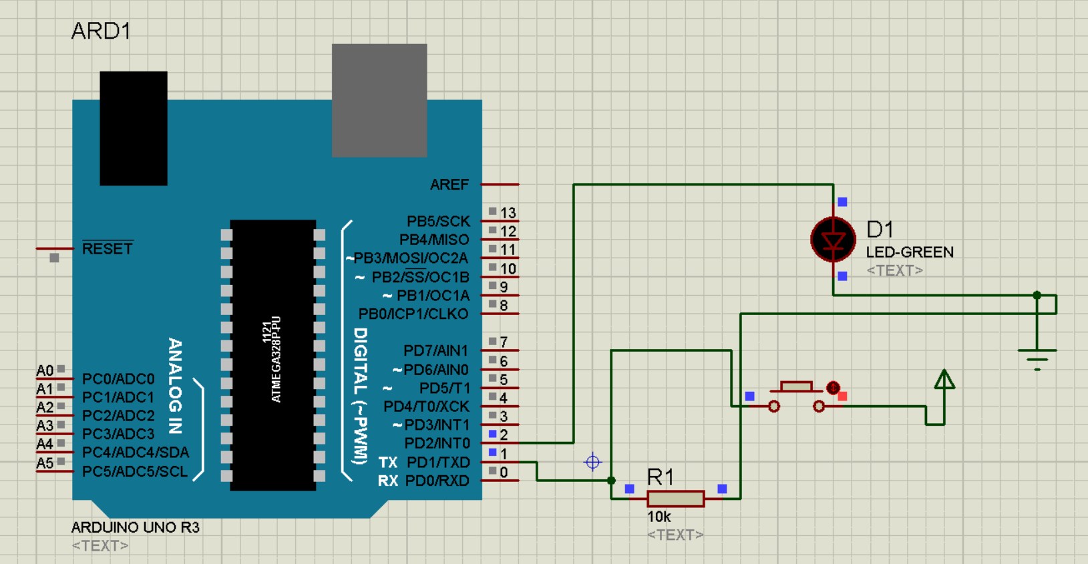

2.2) 2 Switch 2 LED

A).

*Program:*

void setup() {

// put your setup code here, to run once:

pinMode(1,INPUT);

pinMode(2,INPUT);

pinMode(3,OUTPUT);

pinMode(4,OUTPUT);

}

void loop() {

// put your main code here, to run repeatedly:

int a=digitalRead(1);

if(a==1)

{

digitalWrite(3,1);

}

else

{

digitalWrite(3,0);

}

int b=digitalRead(2);

if(b==1)

{

digitalWrite(4,1);

}

else

{

digitalWrite(4,0);

}

}

*Simulation:*

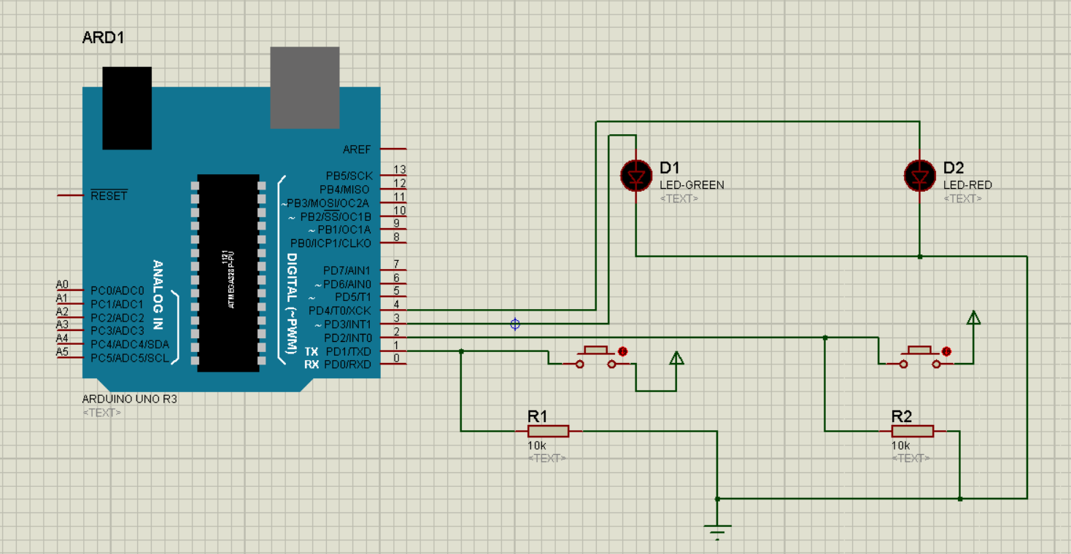

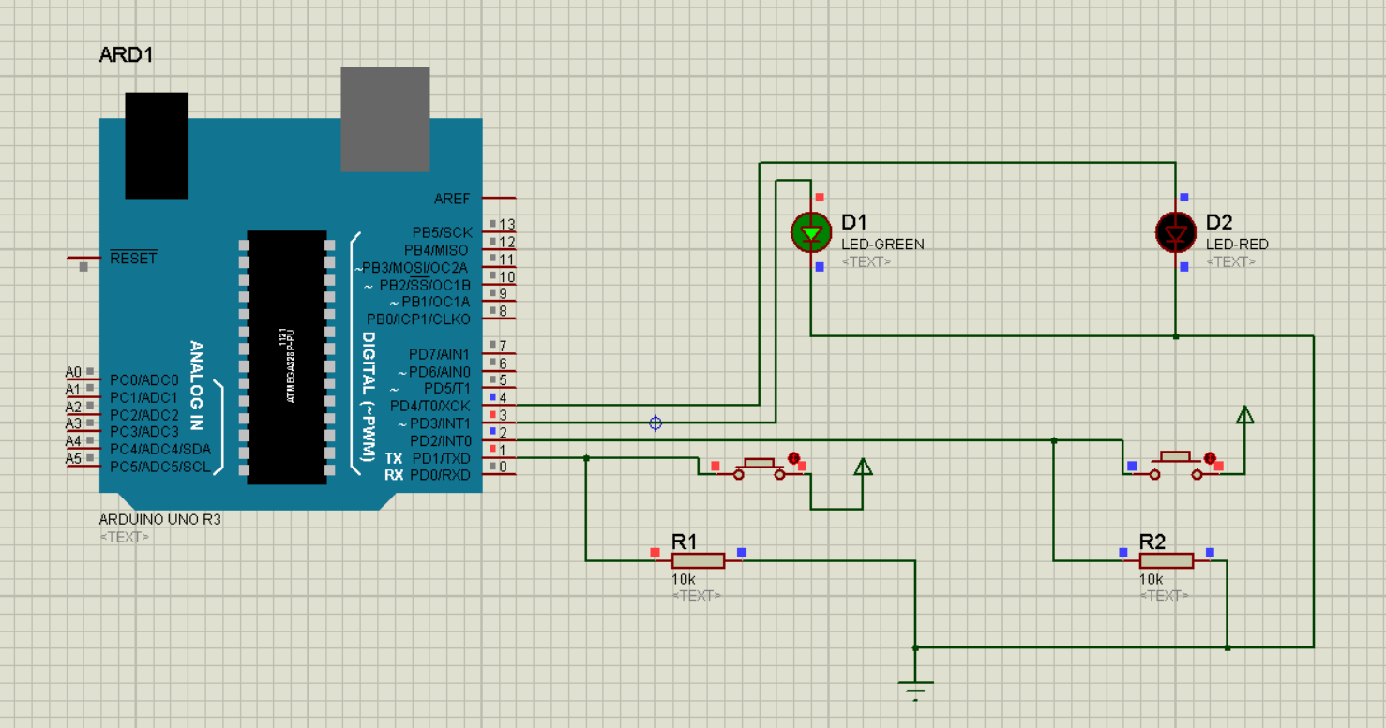

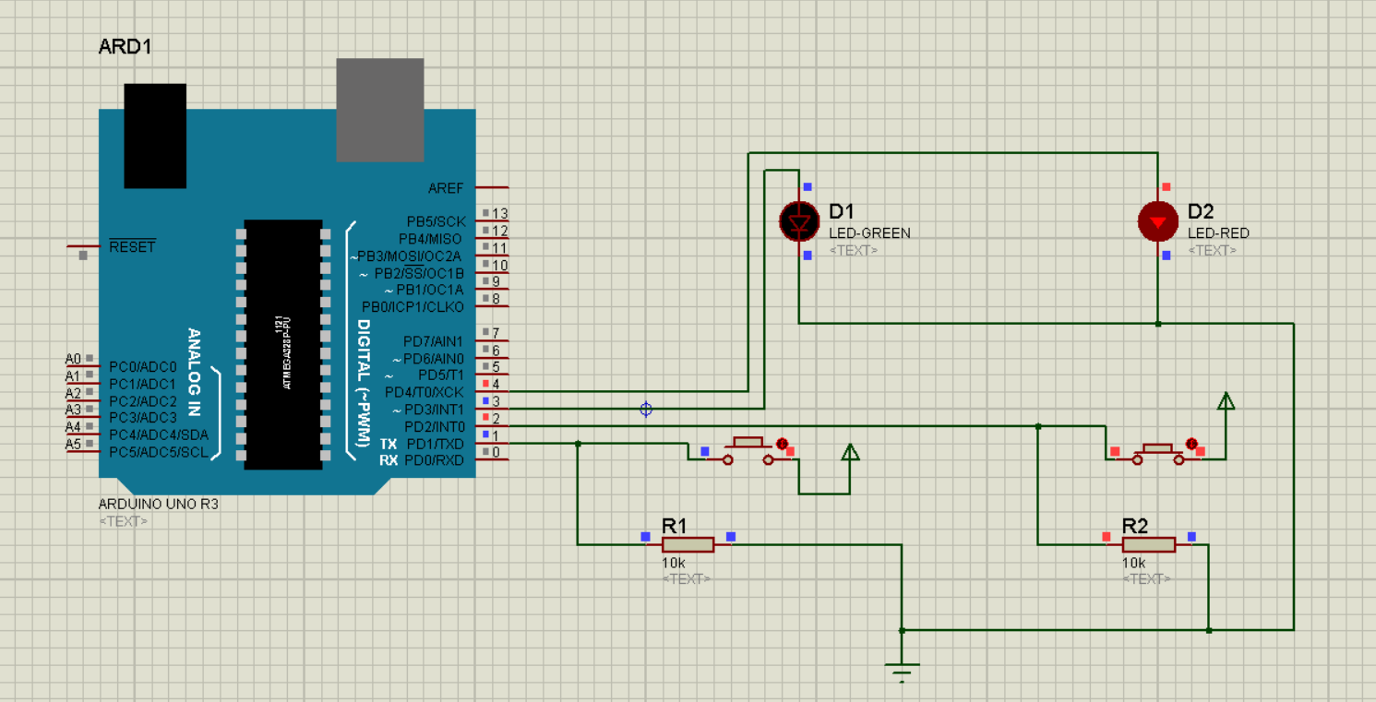

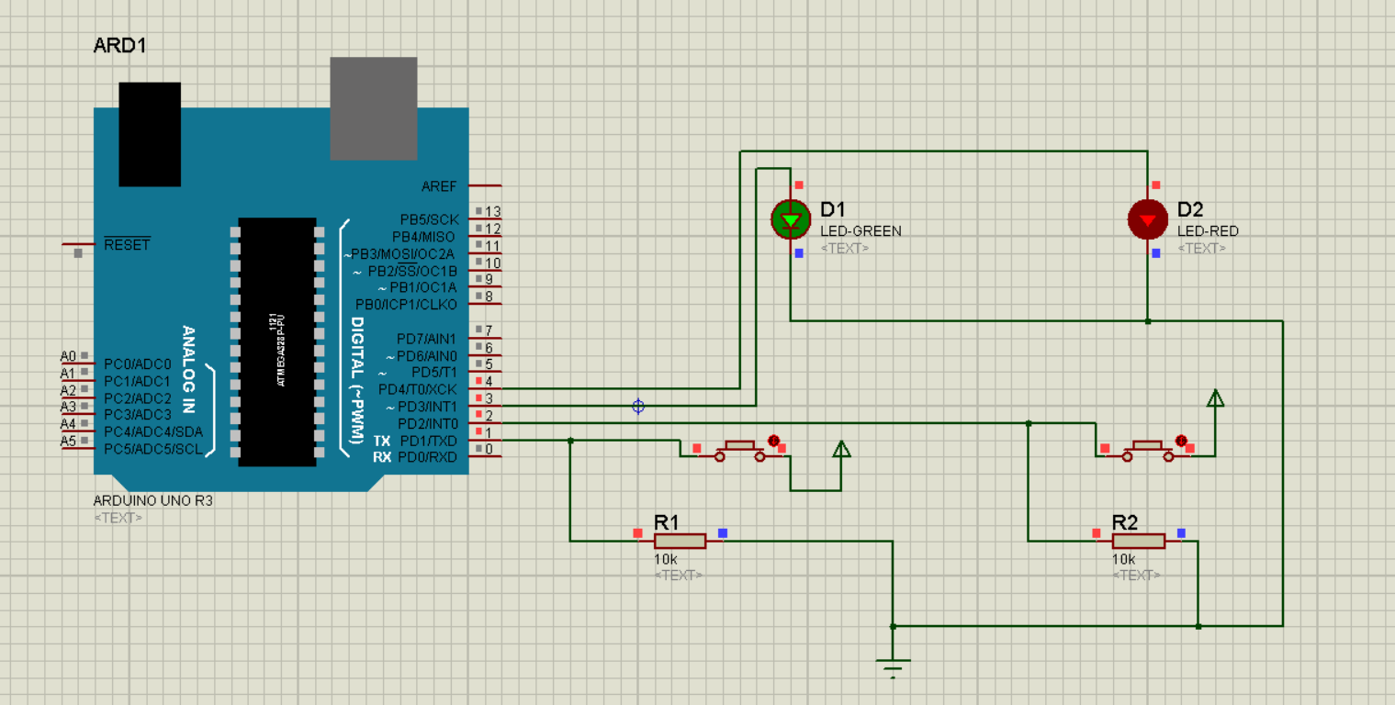

2.3). 2-Switch 3-Led

A).

*Program:*

void setup() {

// put your setup code here, to run once:

pinMode(0,INPUT);

pinMode(1,INPUT);

pinMode(2,OUTPUT);

pinMode(3,OUTPUT);

pinMode(4,OUTPUT);

}

void loop() {

// put your main code here, to run repeatedly:

int a=digitalRead(0);

int b=digitalRead(1);

if(a==1 && b==0)

{

digitalWrite(2,1);

}

else

{

digitalWrite(2,0);

}

if(b==1 && a==0)

{

digitalWrite(3,1);

}

else

{

digitalWrite(3,0);

}

if(a==1 && b==1)

{

digitalWrite(4,1);

}

else

{

digitalWrite(4,0);

}

}

*Simulation:*

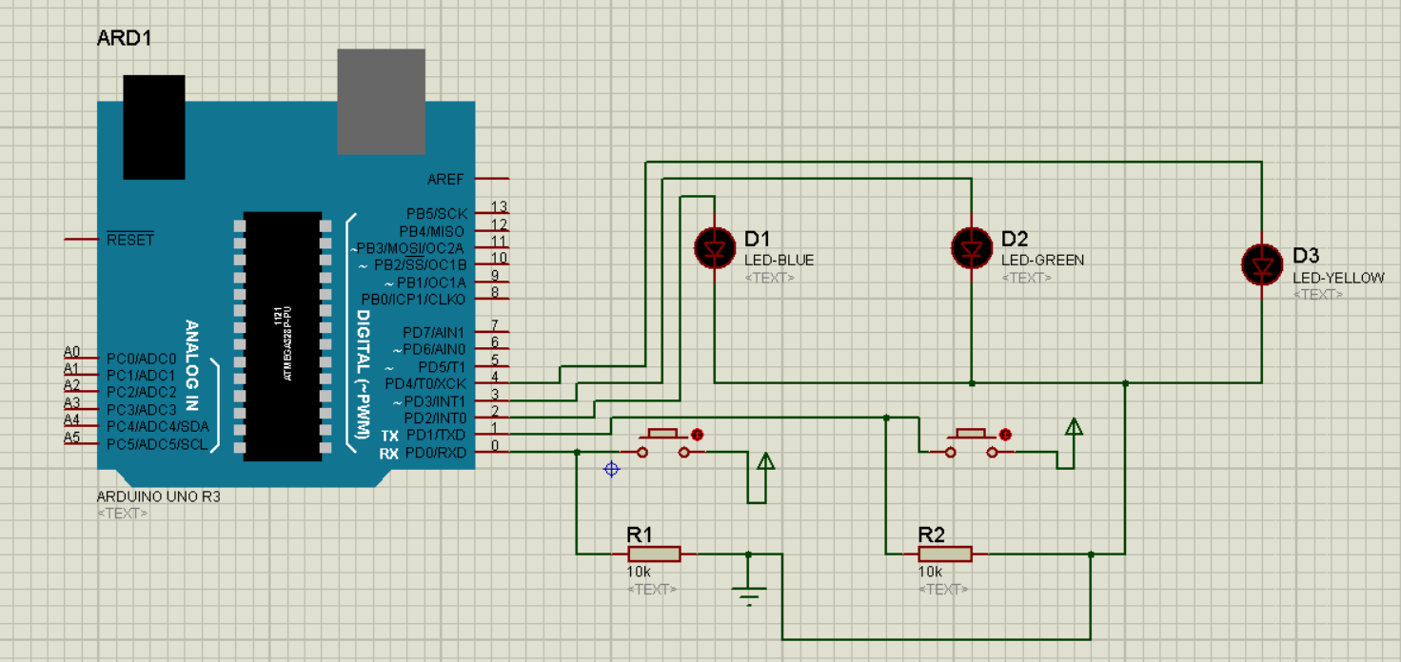

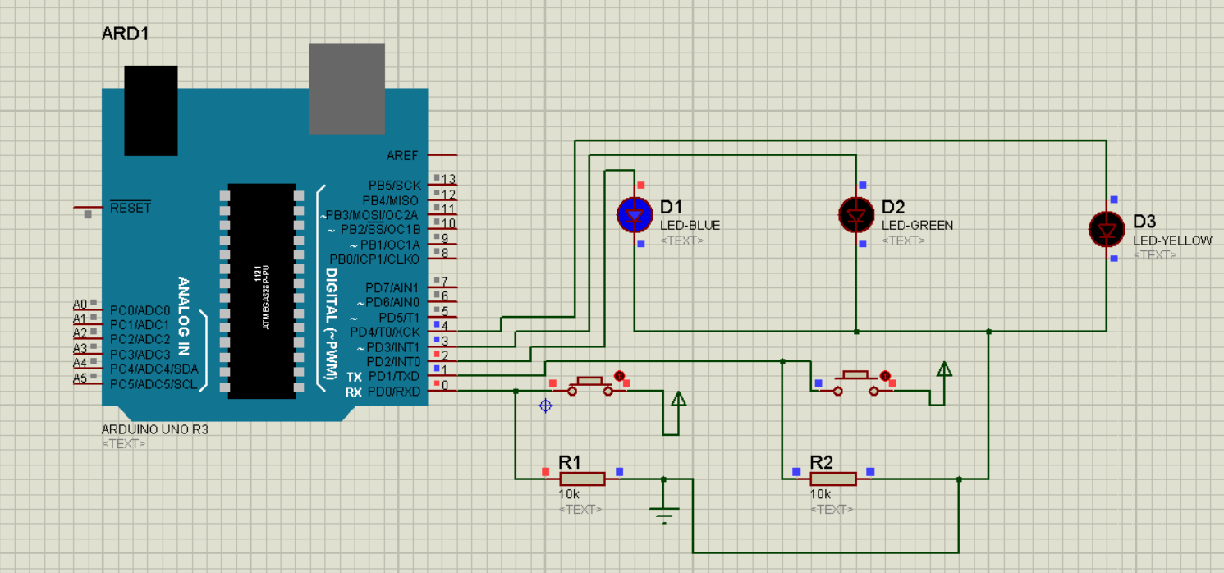

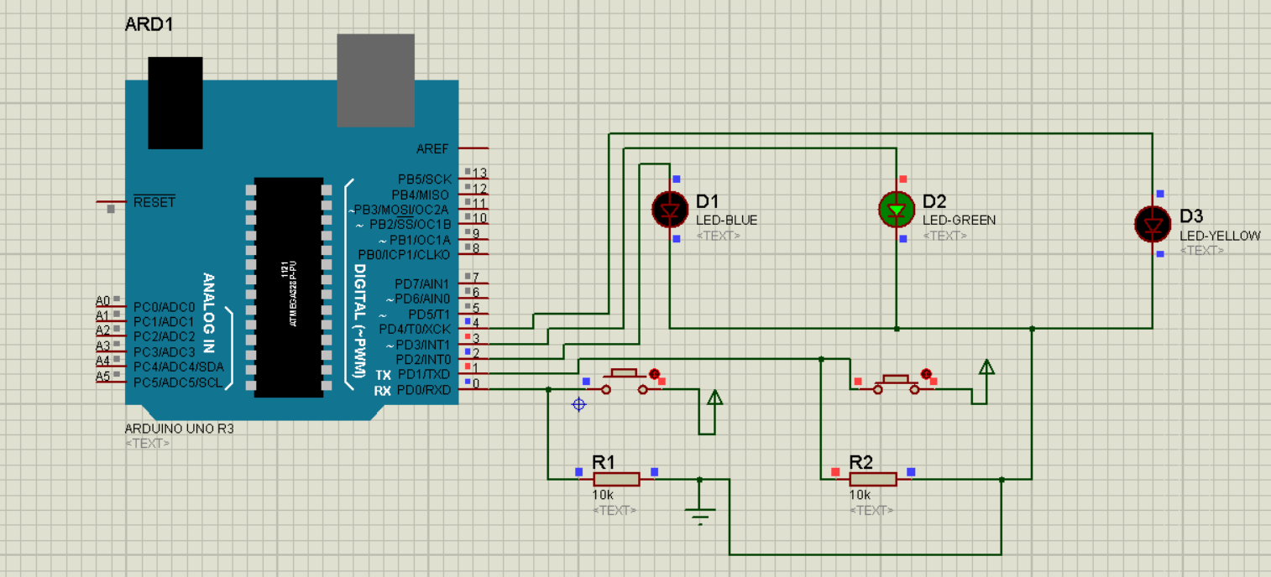

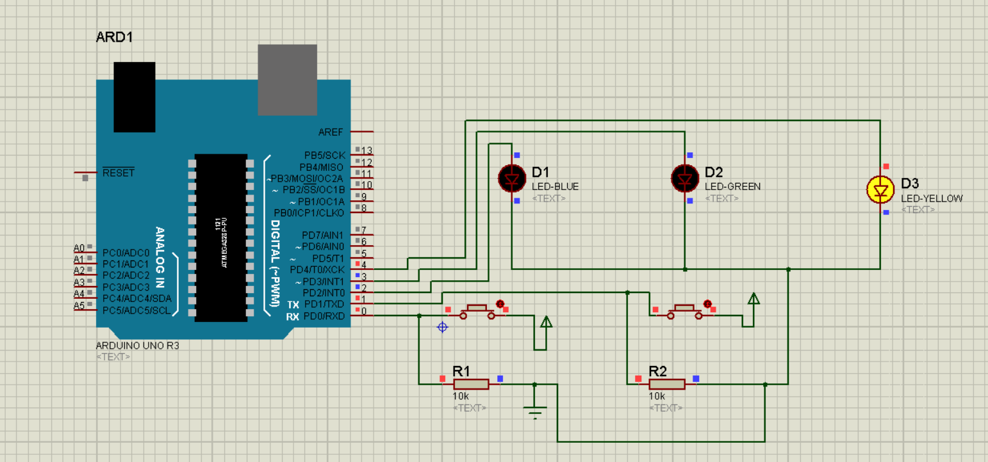

3).Write the Arduino code for ADC and execute the simulation

A).

*Program:*

#include<LiquidCrystal.h>

LiquidCrystal LCD(13,12,11,10,9,8);

void setup() {

// put your setup code here, to run once:

LCD.

begin(16,2);

pinMode(A0,INPUT);

}

void loop() {

// put your main code here, to run repeatedly:

int a=analogRead(A0);

LCD.setCursor(1,0);

LCD.print(a);

}

*Simulation:*

